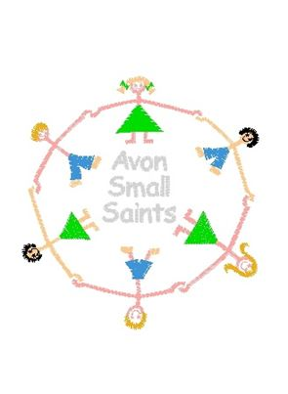
Avon Small Saints Pre-School’s
Collecting your Child Policy

Policy statement

In the event that a child is not collected by an authorised adult at the end of a session/day, we put into practice agreed procedures. These ensure the child is cared for safely by an experienced and qualified practitioner who is known to the child. The child will receive a high standard of care in order to cause as little distress as possible.

Procedures

- Parents of children starting at the setting are asked to provide the following specific information which is recorded on our Registration Form:
- Home address and telephone number - if the parents do not have a telephone, an alternative number must be given, perhaps a neighbour or close relative.
- Place of work, address and telephone number (if applicable).
- Mobile telephone number (if applicable).
- Names, addresses, telephone numbers of adults who are authorised by the parents to collect their child from the setting.
- Who has parental responsibility for the child.
- Information about any person(s) who, for legal reasons, is not allowed access to the child.
- On occasions when parents are aware that they will not be at home or in their usual place of work, they inform us of how they can be contacted.
- On occasions when parents or the persons normally authorised to collect the child are not able to collect the child, they provide us with written details of the name, address and telephone number of the person who will be collecting their child. We agree with parents how to verify the identity of the person who is to collect their child.
- We inform parents that we apply our child protection procedures in the event that their children are not collected from setting by an authorised adult within one hour after the setting has closed and the staff can no longer supervise the child on our premises.
- If a child is not collected at the end of the session/day, we follow the following procedures:
- The child’s file is checked for any information about changes to the normal collection routines.
- If no information is available, parents/carers are contacted at home or at work.
- If this is unsuccessful, the adults who are authorised by the parents to collect their child from the setting – and whose telephone numbers are recorded on the Registration Form – are contacted.
- All reasonable attempts are made to contact the parents or nominated carers.
- The child does not leave the premises with anyone other than those named on the Registration Form or in their file.
- If no-one collects the child after the setting has closed and there is no-one who can be contacted to collect the child, we apply the procedures for uncollected children.
- We contact our local authority children’s social care team:
0300 4560108 | (telephone number)

- The child stays at setting in the care of two fully-vetted workers until the child is safely collected either by the parents or by the a social care worker.
- Social Care will aim to find the parent or relative if they are unable to do so, the child will become looked after by the local authority. If they are unable to collect the child at this time, the local police will be informed.
- Under no circumstances will staff go to look for the parent, nor do they take the child home with them.
- A full written report of the incident is recorded in the child’s file.
- Depending on circumstances, we reserve the right to charge parents for the additional hours worked by our staff.
- Ofsted may be informed:
0300 1231231 | (telephone number)

- Our local Pre-school Learning Alliance office/Pre-school Development Worker may also be informed.
Caroline Drake – 07773 285062 | (name and telephone number)

Parents under the influence of alcohol/substance procedure
- Parent/carer who are under the influence of alcohol or any other substance that may affect their ability to care for that child; when collecting from the pre-school under no circumstance will the staff release the child to their care. See above for relevant procedures to be followed.

Minimum age of person to collect a child
- Any person other than the child’s parent or legal guardian must be over the age of 16 years to collect a child in our care.
- Registration forms have a password recorded, which must be used in order to take the child and we must be informed by parents or legal guardians if somebody different will be collecting their child.

