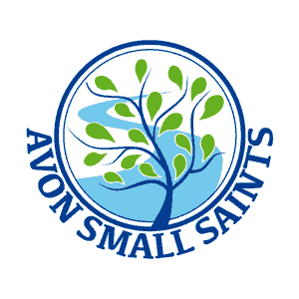

eyLog Registration and Consent

Child’s Name: ____________________________ Date of Birth: ________________________

I have read the information about the eyLog system and understand that by signing this consent form I will receive an email message and will be able to log in and see observations of my child. These observations may include photographs, video clips or audio recordings.

I hereby give consent for my child to be photographed/videoed for record- keeping purposes and for the use of Early Years Professionals at Avon Small Saints Pre-School.

I understand that there may be group photographs/videos that incorporate images of my child and other children and teachers. I agree that these photographs/videos may be used in other children’s learning journeys. To protect and respect privacy, I agree not to use/upload/share the photographs, videos and audio recordings involving other children on public web-sites such as social media websites and may not utilise information from my child’s learning journey for purposes other than understanding the development of my child.

I agree that my child’s observations, learning journey, reports and other documents created through eyLog can be stored on eyLog’s systems. I agree to log in using only the personal log-in provided to me. The following email address(es) can be used to send me notifications through the eyLog system.

Your Name | Your e-mail ID | Relationship to the child | Your Signature

